DOWNTOWN STREETSCAPE PROJECT

Request for Qualifications:
Construction Administration and Observation

The Town of Plymouth has been awarded an NC Commerce Rural Development Downtown Revitalization Grant. These funds will be applied to sidewalk improvements on one block of Water Street between Adams and Washington Streets. The Town is requesting qualifications from interested parties to submit statements of qualifications and experience to design construction plans and provide construction oversight and administration for a redesigned streetscape for a section of Water Street in downtown Plymouth (the streetscape project).

- Submission Requirements

- Proposal Deadline: All proposals are due to Mike Wright, Public Works Director, by November 22, 2023. Late submittals will not be accepted.

- Proposal Submission: Proposals may be submitted in a hard copy or an electronic format. All proposals must be submitted sealed.

- Hard Copy – Proposals should be limited to no more than 20 pages (one side), including project examples but not including title page and table of contents (if used) and mailed to Mike Wright, Public Works Director, Town of Plymouth, 124 East Water Street, Plymouth, NC, 27962; and

- Electronic – Email to: mike.wright@visitplymouthnc.com.

- Project Contact: For questions about the Downtown Streetscape project, please contact Mike Wright, Public Works Director, Town of Plymouth, 124 East Water Street, Plymouth, NC, 27962 by phone at 252-793-9101 ext. 225 or email at mike.wright@visitplymouthnc.com.

- Project Overview

The Town of Plymouth wishes to hire a firm to redesign and oversee construction of one block of Water Street between Adams and Washington Streets. The project will provide a pedestrian oriented, transformative streetscape for Water Street. Commerce grant requirements include improvements to the sidewalks from the curbs to the face of buildings/ROW. The plans should include placement of utility boxes and pull boxes as needed but do not include replacement of underground utilities at this time (most utilities are to the rear of buildings). The Town is seeking firms with documented experience working with communities with characteristics similar to those of the Town of Plymouth, and that can demonstrate previous ability to perform the scope described.

- Project Timeline

The Town of Plymouth intends to have this project ready for construction bidding by June 1, 2024; subsequent to that, the Town intends to begin construction on September 1, 2024 and to have the project finished and closed out by the end of June, 30 2025.

- Scope of Work

- Cost Estimating: The consultant shall demonstrate the ability to provide cost estimation for the streetscape project with confidence and accuracy. The consultant shall be able to provide line-item detail for item costs associated with construction of the streetscape project.

- Survey: A survey of the block and adjoining intersections must be provided as part of the services for this contract.

- Construction Documents: The consultant shall demonstrate the ability to provide construction documents submittals presented to the Town at 50%, 75% and 100% levels. Furthermore, the selected consultant shall be expected to demonstrate the ability to keep in frequent contact on the project without having direction from the Town to do so. The Town is seeking proactive consultants that can seamlessly coordinate with Town staff and construction contractors throughout all phases of the project.

- Bidding Assistance: The consultant shall demonstrate the ability to assist or lead (if necessary) in the preparation of bid documents as well as assistance with the bid and contractor selection process. The consultant will be expected to be able to provide all bid documents including, but not limited to: instructions to bidders, MBE WBE Compliance Statement, bonding and insurance requirements, project manual, etc. The consultant shall demonstrate an ability to provide a full project manual and have the ability (if necessary) to assist in distribution, advertisement, management of bidders, organizing pre-bid conference(s), and issuing addenda.

- Construction Administration/Observation: The consultant shall demonstrate an ability to perform the minimum following tasks: submittal review/response, tree tagging/selection at nurseries, exhibit/bulletin drawings, addenda/change orders, field reports, weekly construction site visits, pay application review/approval, substantial completion of site review, preliminary and final punch lists, and final construction record documents.

- Timeliness

The consultant shall demonstrate the ability to perform the aforementioned scope in a timely manner and in keeping with the project timeline.

- Format of Response

Experience and Capacity for Performance. Consultants should demonstrate their previous ability to manage and administer a project of the scope and scale described. Consultants should provide a brief narrative response that addresses the following:

  - Previous experience in construction design and administration;
  - Brief description of locations where projects similar to this scope were administered;
  - Description of the consultant’s history, structure, and brief review of those who will be designated to this project; and
  - Disclosure of any potential conflict of interest.

- Evaluation Criteria, Scoring, and Selection

- Experience: The consultant shall clearly demonstrate their ability to administer a project of this scope and scale. As part of this, the consultant must demonstrate their performance in communities with similar characteristics to those of the Town of Plymouth. Point value for this criterion is ten (10) points.

- Capacity: The consultant shall clearly demonstrate their capacity to manage the streetscape project. Consultants that demonstrate their dedication of time, number of staff associated with the project, and previous history of their capacity shall receive the highest scores. Point value for this criterion is ten (10) points.

- References: The consultant shall provide references that meet the above criteria. References shall be contacted regarding the ability of the consultant to administer the streetscape project. Consultants whose references indicate a quality performance and working record shall receive the highest scores. Point value for this criterion is five (5) points.

- Scoring: The total possible points shall be twenty-five (25) points. Qualifications shall be reviewed by a minimum of two staff members who will score the qualifications individually, then compare scores to select.

- Selection: The Town of Plymouth reserves the right to select a consultant who best fits the needs of the Town. The Town also reserves the right to re-advertise if it does not feel that the consultants’ submissions meet the needs of the Town.

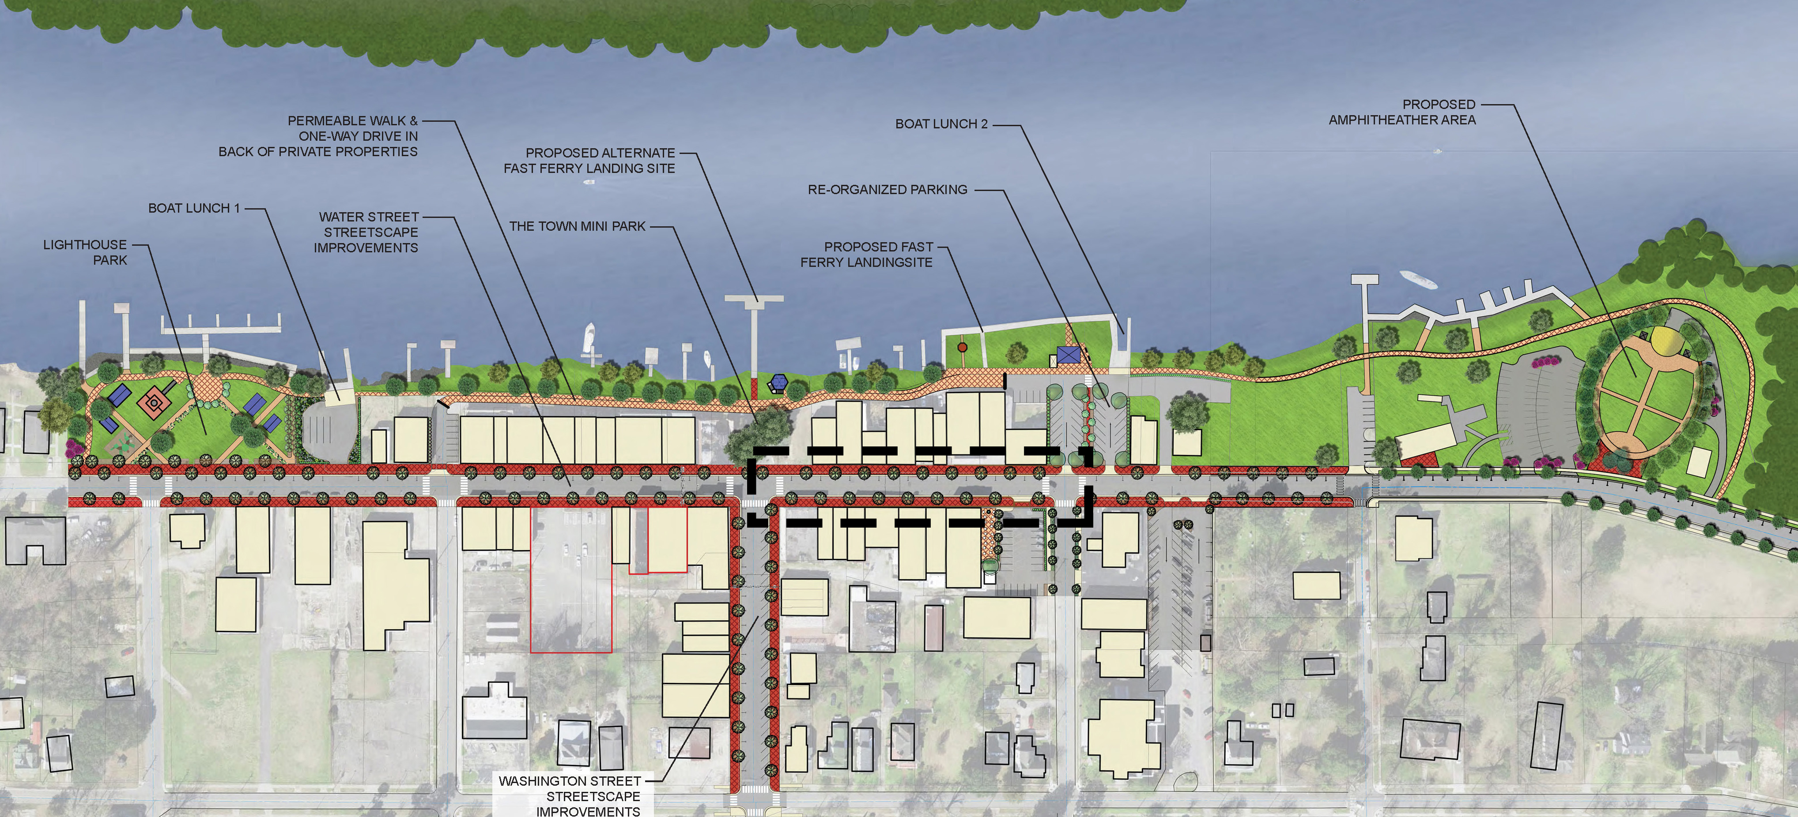

SUBJECT BLOCK WITHIN PLYMOUTH DOWNTOWN AREA – NOT TO SCALE
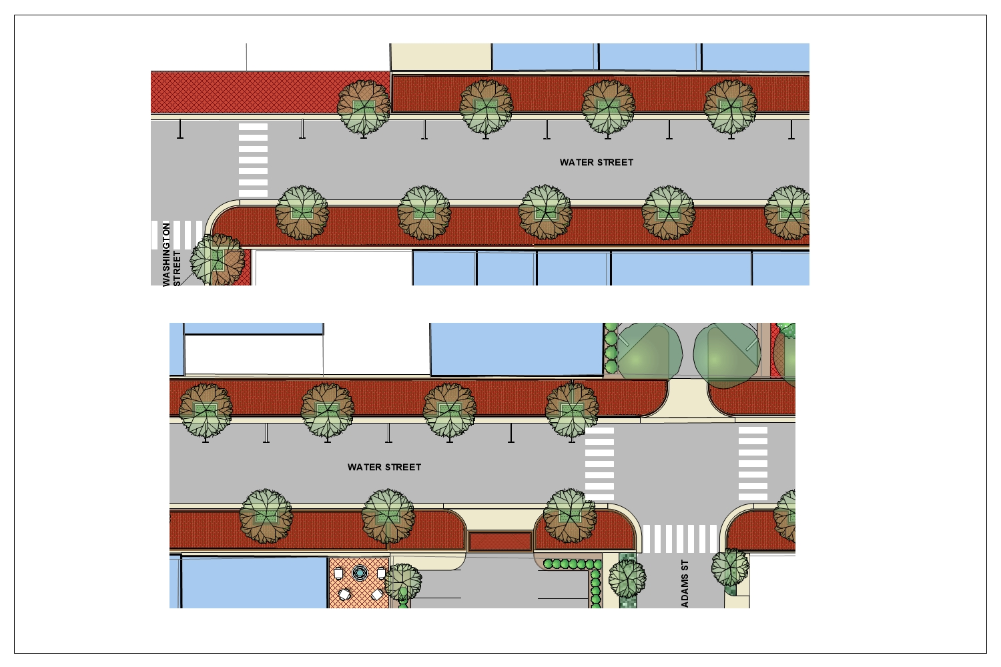
SUBJECT BLOCK – WATER STREET BETWEEN ADAMS & WASHINGTON STREETS
NOT TO SCALE

These drawings are part of a master plan drawing.
Actual sidewalk and street widths, parking configurations and
materials are yet to be determined.

